**Steps to Upload Data Manually**

1. First Install Sanity CMS in the Next.js Project
2. Made Schemas for the **Food** and **Chef.**
3. Navigate to <http://localhost:3000/studio>
4. Upload Manual Data to Sanity.

**Here are some Screenshots:**

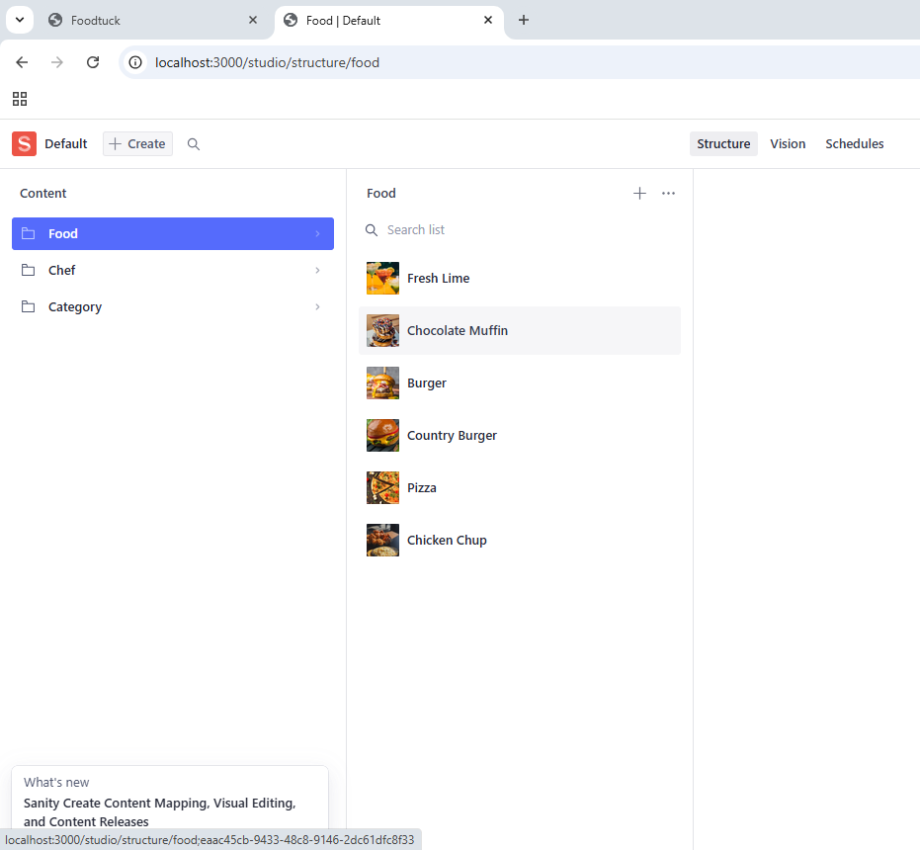

Here are some Screenshots for fetching food and chef data from sanity to Next.js Project.

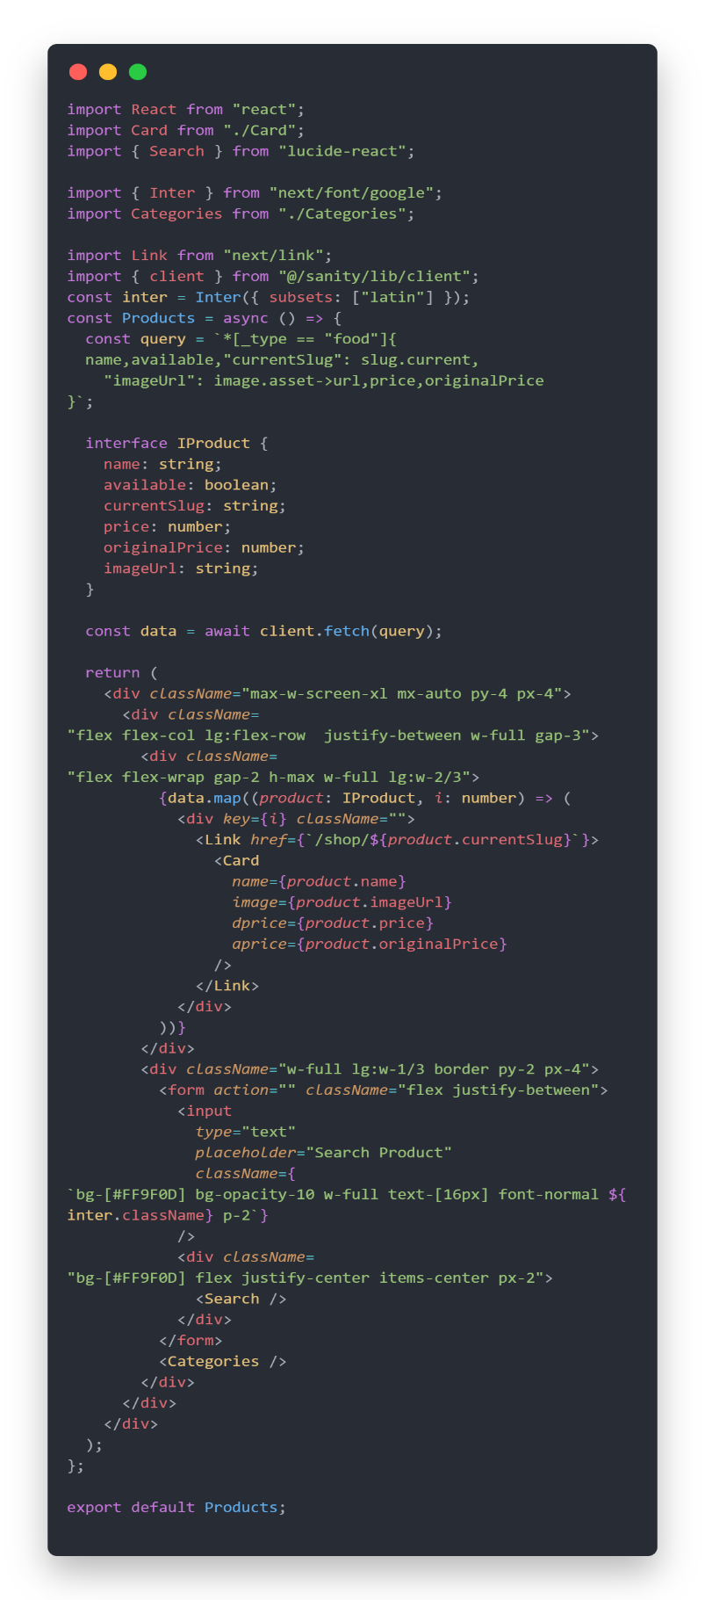 **Query For Food**

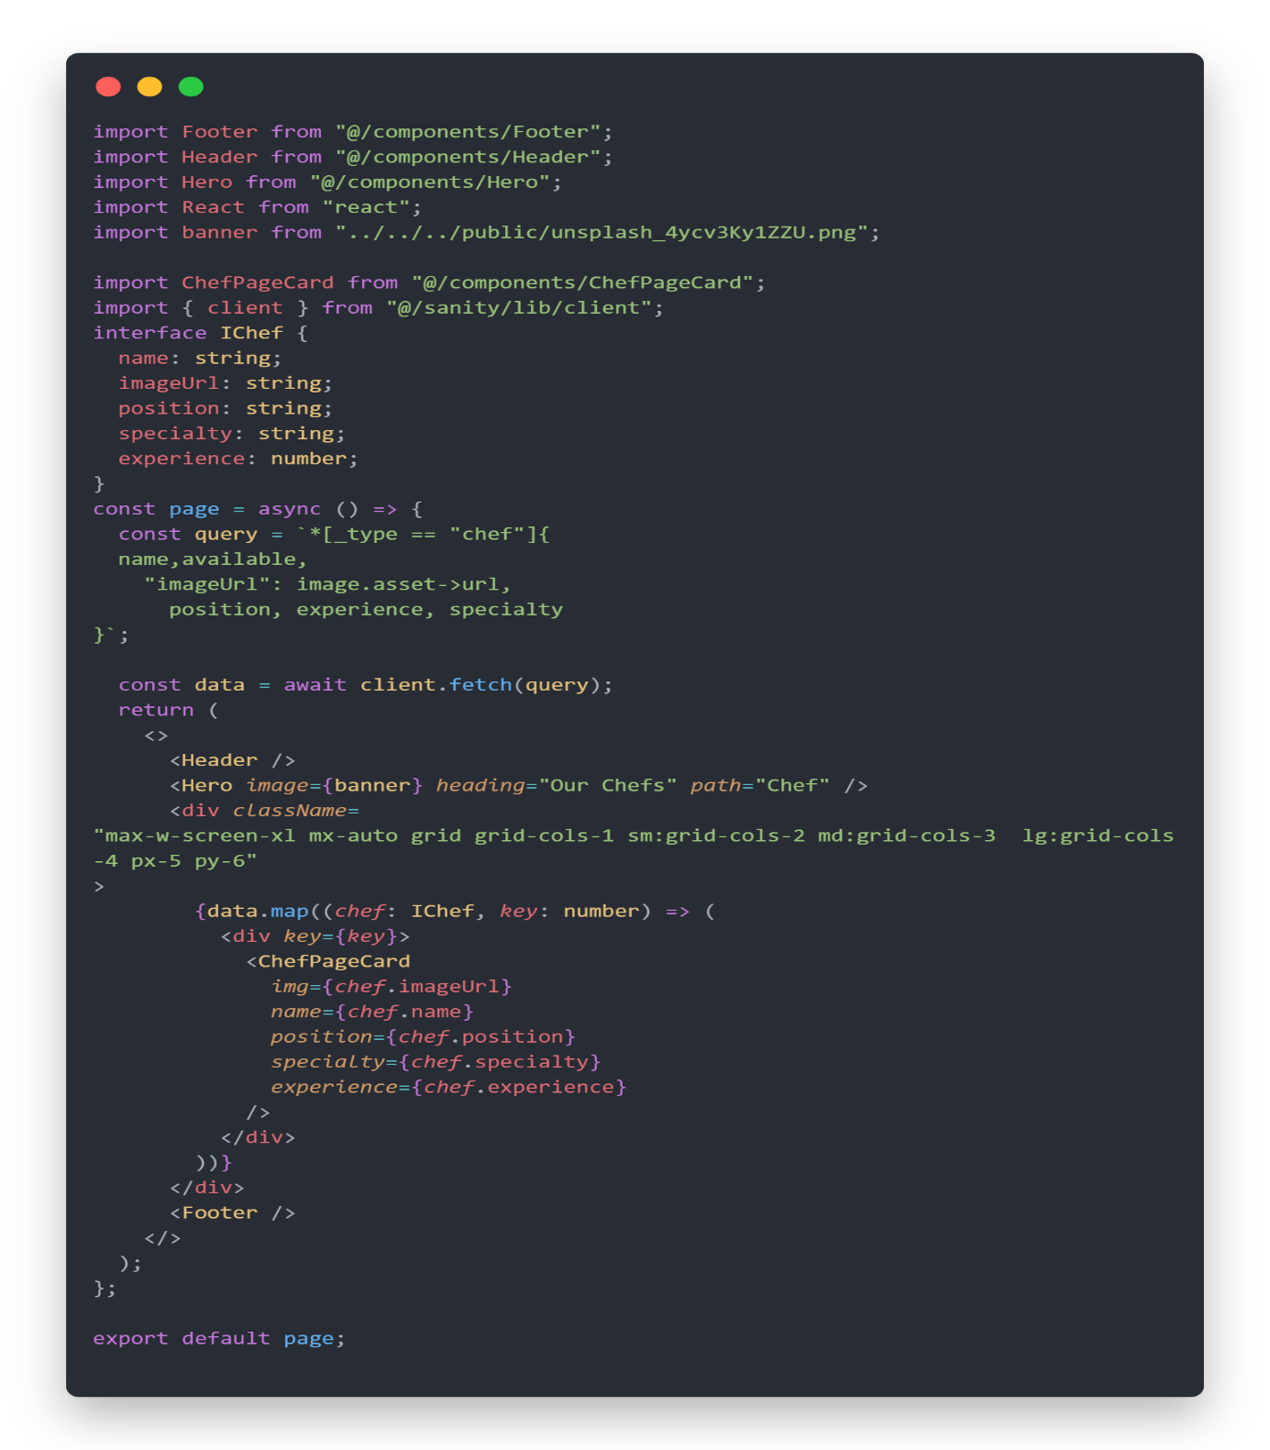**Query For Chef**

|  |  |  |  |  |
| --- | --- | --- | --- | --- |
| **API Understanding:** | **Schema Validation:** | **Data Migration:** | **API Integration in Next.js:** | **Submission Preparation:** |
| **✔** | **✔** | **✔** | **✘** Manual Upload data to sanity and fetch. | **✔** |